**Module 3 Activity 3: Middleware**

**Part A - B**

Gustavo Olgiati

Ira A. Fulton Schools of Engineering, Arizona State University

Professor Dinesh Sthapit

September 24, 2023

Screen Captures

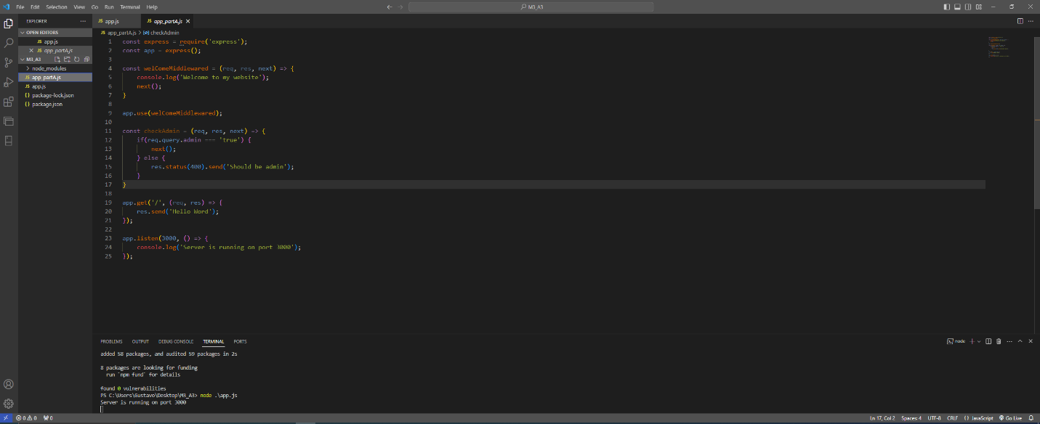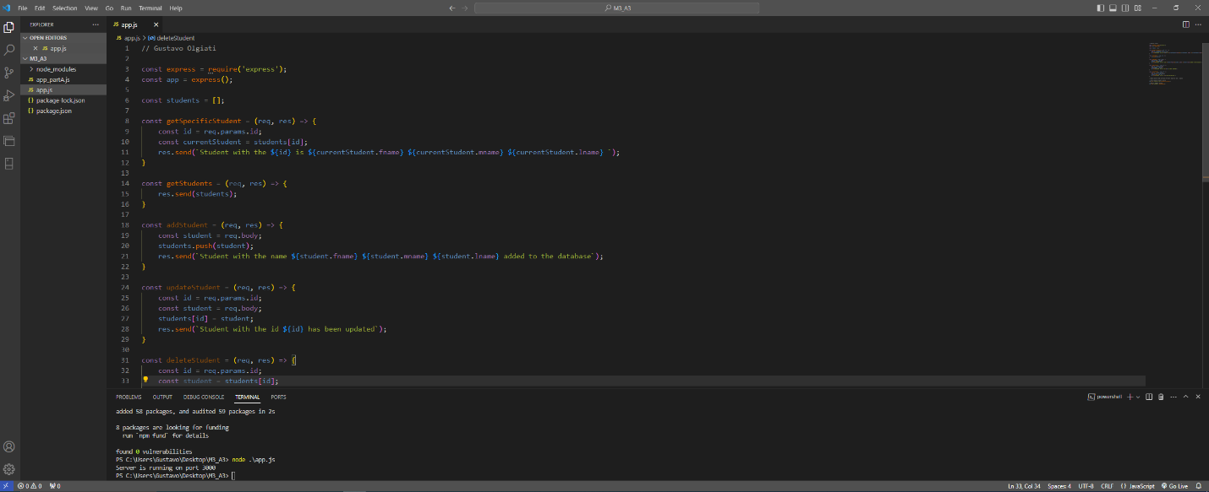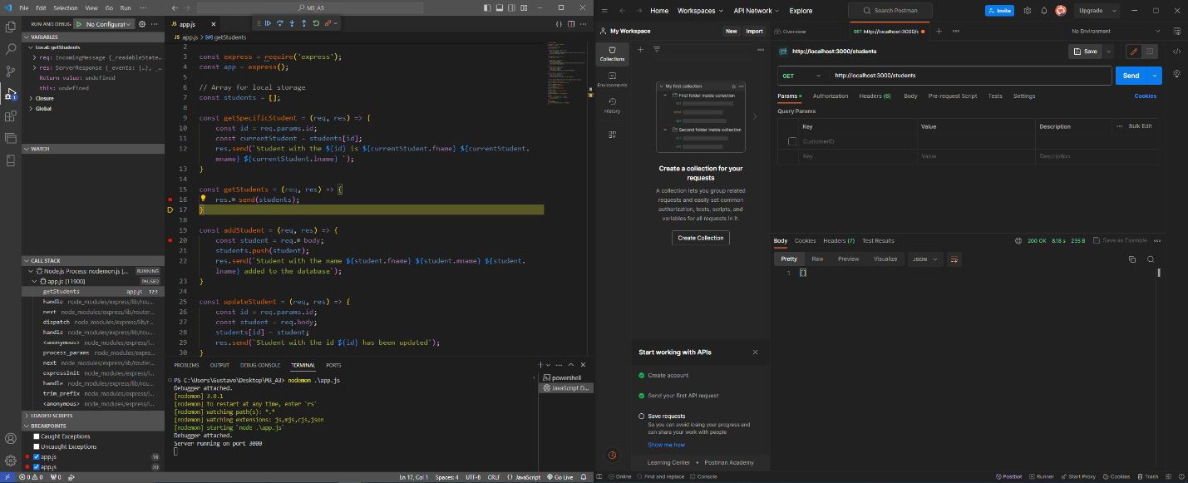

Part B

